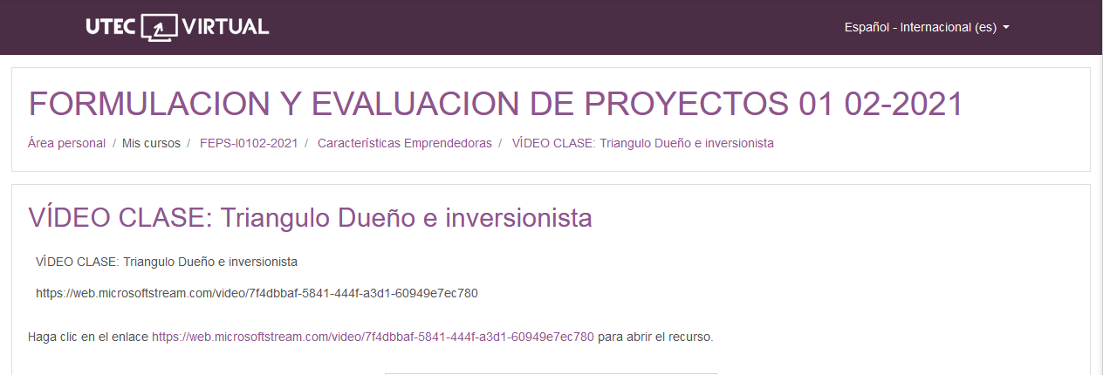

<https://web.microsoftstream.com/video/7f4dbbaf-5841-444f-a3d1-60949e7ec780>